Supporting Information
SuccFind: a novel succinylation sites online prediction tool via enhanced characteristic strategy
Hao-Dong Xu¹, Shao-Ping Shi², Ping-Ping Wen¹, Jian-Ding Qiu^{1, 3*}
¹ Department of Chemistry, Nanchang University, Nanchang 330031, P.R.China
² Department of Mathematics, Nanchang University, Nanchang 330031, P.R.China
³ Department of Materials and Chemical Engineering, Pingxiang College, Pingxiang 337055, P.R.China
*To whom correspondence should be addressed. Tel: + 86 791 83969518; Email: jdqiu@ncu.edu.cn

Table of Contents
- Supplementary Experimental Procedures
Ep1. Sequence-derived characteristics
Ep2. Evolutionary information
Ep3. Feature optimization and selection
Ep4. Information gain (IG)
Ep5. Succinylation prefer to in situ crosstalk with acetylation
Ep6. Succinylation involved in diverse metabolic pathways
- Supplementary Tables
Table S1. Predicted succinylation sites on known acetylated substrates, which were collected from H. sapiens (HS), M. musculus (MM), R norvegicus (RN), D. melanogaster (DM), S cerevisiae (SC) and E coli (EC).
Table SS1. A summary of two type features: annotation and dimensionality. Features can be classified into two major categories: sequence-derived features, evolutionary-derived information.
- Supplementary Figures
Fig.S1. The graphical representation of biochemical environment surrounding succinylation sites using different grouping method. ªRedundant sequence is eliminated from each group sequence. ^{b}Each symbol in the stack of group logo represents each class in the group column
Fig.S2. Amino acid average composition of succinylation and non- succinylation sites.
Fig.S3. Heatmap indicating the weight distribution of k-space scores of amino acid pairs. (a) k=1.
(b) k=2. (c) k=3.
Fig.S4. The in situ crosstalk between succinylation with acetylation across different species.
Fig.S5. The enriched GO terms for proteins with in situ crosstalk between succinylation- acetylation in comparison with acetylated proteins.
Fig.S6. The enriched KEGG annotations for proteins with in situ crosstalk between succinylation-acetylation in comparison with acetylated proteins.
Fig.SS1. Optimization of CKSAAP encoding by F-score strategy with 10-fold cross-validation.
Fig.SS2. Optimization of isoelectric point by F-score strategy with 10-fold cross-validation.
Fig.SS3. Optimization of AAC by F-score strategy with 10-fold cross-validation.
Fig.SS4. Statistical analyses of GO annotations (Biological processes) for succinylated proteins.
Fig.SS5. Statistical analyses of GO annotations (Molecular functions) for succinylated proteins.
Fig.SS6. Statistical analyses of KEGG annotations for proteins of succinylated.

- Supplementary References

- Supplemental experimental procedures
Ep1. Sequence-derived characteristics
Amino Acid Composition (AAC) Encoding
All organisms try to minimize the cost of protein synthesis by adjusting their amino acid content to specific growth conditions, a proteome-wide amino acid composition analysis can characterize the specific state of a given succinylated and non- succinylated poteins. We found that there are differences between positive and negative samples of succinylated fragments in term of amino acid composition while amino acid compositions can be useful features for many PTMs sites prediction. Hence, in this work, AAC was used in the same manner as the researchers described. We calculated the amino acid frequencies in the sequence surrounding the query site (the site itself is not counted). There are 20 types of amino acids, and thus 20 frequencies are calculated, the sum of which is 1.
The Composition of K-spaced Amino Acid Pairs (CKSAAP) Encoding
In this paper, a succinylation site is presented by a fragment of 21 residues with the residue lysine (K) in the central position. And CKSAAP encoding reflects the composition of k-spaced amino acid pairs (i.e., pairs that are separated by k other amino acids) within this sequence fragment. This feature vector is then adopted to represent the composition of these pairs and further to build our model, which can be described as follows:
（C_{AA} C_{AC} A_{AD} …… C_{OO} )₄₄₁
The value of each feature of CKSAAP encoding denotes the composition of the corresponding amino acid pair in the fragment. For example, if an AA pair appears m times in a succinylation fragment, the composition of the AA pair in the vector (i.e., C_{AA}) is equal to m. The amino acid pairs for k=0, 1… k_{max} are jointly considered in this study. Therefore, the total dimension of the proposed feature vector is 441×(k_{max}+1). In our work, we define the k_{max} as equal to 3 when considering the dimension and overall performance.
AAindex
Amino Acid index database (AAindex) contains a total of 544 amino acid indices, which includes a number of published indices that specify the physicochemical properties of amino acids. Therefore, according to the values associated with each physicochemical property, the amino acids adjacent to the succinylation sites can be encoded as an input vector to develop our prediction model. And the amino acid indices with the value “NA” were replaced by 0 in this feature. We have examined all of the 544 physicochemical properties with the default parameters of SVM to investigate the contribution of each physicochemical property to build the model. Finally, isoelectric point was chosen as the best physicochemical property (with high accuracy) for succinylation prediction from AAindex.
Ep2. Evolutionary-derived information
LSC Encoding.
LSC score encoding scheme is based on the concept of the nearest neighbor algorithm, which is a method for classifying a new object according to the K closest samples in the feature space. Local sequence clusters often exist around succinylation site because substrate sites of same enzyme usually share similar patterns in local sequence fragments. To take advantage of such cluster information of local sequence fragments for predicting succinylation sites, we took the local sequence around the succinylation site in a query protein and extracted features from its similar sequences in both positive and negative datasets by a LSC score algorithm.
For a query succinylation site, we first find its K nearest neighbors in both positive and negative sets according to local sequence similarity. For example, for two local sequence fragments S₁ and S₂ (the window size is 2n+1), define the distance D (S₁,S₂) between S₁ and S₂ as:
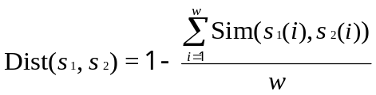
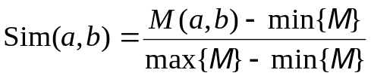
where, Sim is derived from the normalized amino acid substitution matrix. a and b are the two amino acids, M is the substitution matrix (BLOSUM62 was used in this paper).
After that, the corresponding LSC score was then extracted as follows: (i) Calculate the average distances from the query sequence fragment S to all the training set (contain the positive and negative sets); (ii) Sort the neighbors by the distances and choose the K nearest neighbors; (iii) Calculate the percentage of positive neighbors in its K nearest neighbors as the LSC score. Last, to take advantage of different properties of neighbors with various similarities, we chose different K values to obtain multiple scores. In this paper, K was chosen to be 0.05%, 0.1%, 0.2%, 0.4% and 0.8% of the size of the training set, and the five LSC scores were extracted as features for succinylation prediction
Ep3. Feature optimization and selection
These above features that we adopt to develop our system are consist of many dimensions, some of which may not be valuable to the prediction of succinylation sites and they could be also redundant with each other because of the specificity of the succinylated substrates. Therefore, we introduced a feature selection method known as F-select to remove the irrelevant and redundancy feature vectors. The selection method was performed using the 10-fold cross validation strategy for each of the ten training sets as follows. First, averaged F-score values of the each ten training sets were calculated with the purpose of ranking the features vector. We used a wrapper-based feature selection with the forward best first search. More specifically, for a given list of feature F = [fi where i= 1, 2… n] sorted in the descending order by their average F-score value and an empty list R that store the selected features. We add the top-ranked feature from F to R and run SVM using feature set R in the cross validation strategy. If the addition of the top ranked feature improves the average accuracy value over the ten test folds, then this features vector is retained in R; otherwise it will be removed. We repeat that until F is empty. Finally, the SVM classifier is trained to distinguish succinylation and non-succinylation sites on the selected feature set. The F-score of ith feature is defined as;
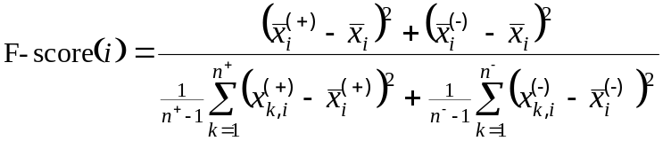
Where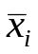, 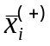 and 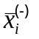 are the average value of the ith feature in whole, positive and negative data sets, respectively. 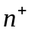 denotes the number of positive data, 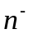 denotes the number of negative data, 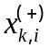 denotes the ith feature of the kth positive instance, and 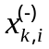 denotes the ith feature of the kth negative instance.
This study have assessed multiple features and eventually adopted 4 encodings schemes (Table SS1) including AAC encoding, CKSAAP encoding, AAindex and LSC score based on biological characteristics of sequence, evolutionary-derived information surrounding succinylation and non-succinylation sites, and further optimized by F-score to choose the optimal dimensions of different characteristics (Fig.SS1,SS2,SS3) as the input vector to train our model. (The dimension of LSC score is too little and without optimization).
Ep4. Information gain (IG)
To obtain new information from the data, we require a good measure for the uncertainty of the given data and the uncertainty between the predicting information and the given data. The information entropy from information theory, which was developed by Shannon , provides an effective measure of the uncertainty for a given system. It has been confirmed that the physical entropy used in thermodynamics is more or less closely related to the concept of information used in communication theory. Therefore, information gain (IG), which measures the decrease in information entropy when a given variable is used to group values of another (class) variable, can also be considered to be a measure of the degree of ordering .
In fact, for a given protein sequence fragment, the conservative property varies from site to site, and some residues near the central site have little contribution to the identification of the modify sites. Thus, the current problem is how to choose the specific residues that have a positive influence on the predictive models. In our solution we choose a correlation measure based on the information-theoretical concept of IG, a measure of the uncertainty of a random variable. Here, we define the information entropy H_{c}(X) of each amino acid residue in all sequence fragments as the following:
and the entropy of X after observing values of another variable Y is defined as:
where n is the length of the sequence fragments, P_{c}(x_{i}) is the prior probabilities for succinylation and non-succinylation sites in all sequence fragments, P_{c}(y_{j}) is the probability of the jth amino acid occurring in position c in those fragments, and P_{c}(x_{i}|y_{i}) is the posterior probabilities of jth amino acid in succinylation and non-succinylation sequence fragments. The amount by which the entropy of X decreases reflects additional information about X provided by Y and is called information gain [24]
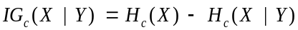
According to the above theory, we can draw the conclusion that the larger the value of IG is, the greater the impact of the corresponding amino acid residue on the succinylation site.
Ep5. Succinylation prefer to in situ crosstalk with acetylation
We totally collected 56905 acetylation sites from the public databases. By integrating the datasets together with succinylation data set, we are surprised to detect that 2422 succinylation sites in our study could co-occur at the same lysine residues with acetylation. .
With the high stringency value, we adopted SuccFind to predict potential succinylation sites in lysine acetylated substrates. Totally, it was observed that 10128 (17.80%) known acetylation sites might be modified by succinylation, which declare that succinylation sites are extensive crosstalks with acetylation at the same lysine residues.
As acetylation has been extensively mapped in diverse organisms, we then explored the in situ crosstalk between succinylation and acetylation across different species to explore the species specificity. We only predicted succinylation sites on known acetylated substrates which were collected from H. sapiens (HS), M. musculus (MM), R norvegicus (RN), D. melanogaster (DM), S cerevisiae (SC) and E coli (EC). The statistical results suggested that succinylation sites prefer to occur at acetylated lysines rather than non-acetylated lysines with the p-values of (1.41E-319) (Table S1). After compared the succinylation sites identified in our study to previously determined acetylation collecting from different database, we detected that 32% of human, 50% of musculus, 45% of norvegicus, 31% of melanogaster, 41% of cerevisiae, and 74% of coli succinylation sites were acetylated (Fig.S4) at the same position. Therefore, the results suggest that the preference of the in situ crosstalk may not only be rely on the PLMs types, but also exhibit a tissue-specific manner. However, because the large-scale data set of tissue-specific succinylation sites is still not available, whether the preference of in situ crosstalks of lysine modifications will be changed in different tissues or organs remains to be dissected.
With the Fisher-exact test, we statistically analyzed the over- or under-represented GO terms in acetylated substrates which also be competitively regulated by succinylation at the same lysines (Fig.S5, S6). We only considered the succinylated proteins whose modified sites were known acetylation sites. Clearly, we found that succinylation prefers to in situ crosstalk with acetylation in a variety of biological processes, such as oxidation reduction (GO:0055114), monocarboxylic acid metabolic process (GO:0032787), and generation of precursor metabolites and energy (GO:0006091). And the most important functional entry that succinylation-acetylation crosstalk site perform is oxidoreductase activity (GO:0016491). Moreover, all succinylation-acetylation proteins were mapped to the Kyoto Encyclopedia of Genes and Genomes (KEGG) pathways and performed the statistical analyses of pathways for the in situ crosstalks. The results suggested that the succinylation-acetylation crosstalk is significantly enriched in pathways of valine, leucine and isoleucine degradation and some of the metabolism as well as Huntington's, Parkinson's and Alzheimer's disease.
Taken together, these observations show that succinylation prefer to co-occupy with acetylation at the same lysine residues. And in situ crosstalk between succinylation and acetylation might exhibit a tissue-specific manner. Gene functional analysis suggested that succinylation prefers to in situ crosstalk with acetylation in a variety of biological processes and pathway.
Ep6. Succinylation involved in diverse metabolic pathways
Increasing evidence suggests that lysine succinylation dynamically regulates enzymes in metabolism. In order to explore this issue, functional analyses have been performed between succinylation and metabolism.
We first statistically analyzed the enriched biological processes and molecular functions with the gene ontology (GO) annotations with Fisher-exact test (Two-sided category) for succinylated substrates, of which the top 10 statistically over-represented terms of these two criteria are shown (Fig.SS4, SS5). For the biological processes, the most significant processes of succinylation are multifarious metabolic processes (GO:0008152) such as oxoacid, carboxylic and organic acid metabolic process (GO:0043436; GO:0019752; GO:0006082), cellular ketone metabolic process (GO:0042180), generation of precursor metabolites and energy (GO:0006091), cellular, coenzyme and cofactor metabolic process (GO:0044237; GO:0006732; GO:0051186). Among top 10 most significant processes of succinylation, 9 terms are associated with metabolism. For molecular functions, the most apparent GO terms are enzyme catalysis related such as catalytic activity (GO:0003824), lyase activity (GO:0016829) and oenzyme binding (GO:0050662) etc.. These results suggest that lysine succinylation portray a crucial role in accommodating metabolic mechanisms in cellular biologic processes.
We then performed Kyoto Encyclopedia of Genes and Genomes (KEGG) pathway enrichment analysis to further explore functional aspects of succinylated substrates. The top 10 statistically significant results (P<0.05) were listed in Fig.SS6. From the results, we could detect that many metabolic pathways were significantly enriched within the group of succinylated proteins including valine, leucine and isoleucine degradation, citrate cycle (TCA cycle), butanoate metabolism, fatty acid metabolism, propanoate metabolism etc. Except a number of diseases pathways, a large portion of succinylated substrates were involved in metabolic pathways.
To sum up, functional analysis reveals potential impacts of lysine succinylation on enzymes involve in mitochondrial metabolism and other cellular processes that metabolism related.

2. Supplementary Tables
Table S1. Predicted succinylation sites on known acetylated substrates, which were collected from H. sapiens (HS), M. musculus (MM), R norvegicus (RN), D. melanogaster (DM), S cerevisiae (SC) and E coli (EC). Statistical significance was determined by Fisher exact test. ªThe number of known acetylated substrates. ^{b}The number of all lysine residues of acetylated substrates; ^{c}The number of known acetylation sites; ^{d}The number of totally predicted succinylation sites of all lysine residue. ^{e}The number of predicted succinylation sites on known acetylated residues.^{f}The percentage of predicted succinylation sites on known acetylated residues;

Organism | Acetylation |  |  | Succinylation |  |  | p-value
Organism | Subª | Total^{b} | Site^{c} | Total^{d} | Site^{e} | Per^{f} | p-value
HS | 4648 | 209405 | 10128 | 5645 | 1785 | 17.62 | 3.03E-320
MM | 3960 | 158152 | 12694 | 5331 | 2664 | 20.99 | 3.06E-320
RN | 4421 | 176843 | 13966 | 5528 | 2515 | 18.01 | 3.10E-320
DM | 1207 | 58227 | 2369 | 1541 | 480 | 20.26 | 1.66E-209
SC | 1368 | 58328 | 4284 | 2088 | 852 | 19.89 | 2.24E-269
EC | 1818 | 29719 | 8631 | 2253 | 1662 | 19.27 | 1.90E-151
Total | 17422 | 690674 | 52072 | 22386 | 9958 | 19.12 | 1.41E-319

Table SS1. A summary of two type features: annotation and dimensionality. Features can be classified into two major categories: sequence-derived features, evolutionary-derived information.

Feature type | Annotation | The total number of dimension before optimization | The total number of dimension after optimization
Sequence-derived features | Amino Acid Composition (AAC) | 20 | 20
Sequence-derived features | The Composition of K-spaced Amino Acid Pairs (CKSAAP) | 1670 | 417
Sequence-derived features | AAindex | 21 | 21
Evolutionary-derived information | Local sequence clusters score (LSC score) | 5 | 5
Total | 4 | 1716 | 443

3. Supplementary Figures
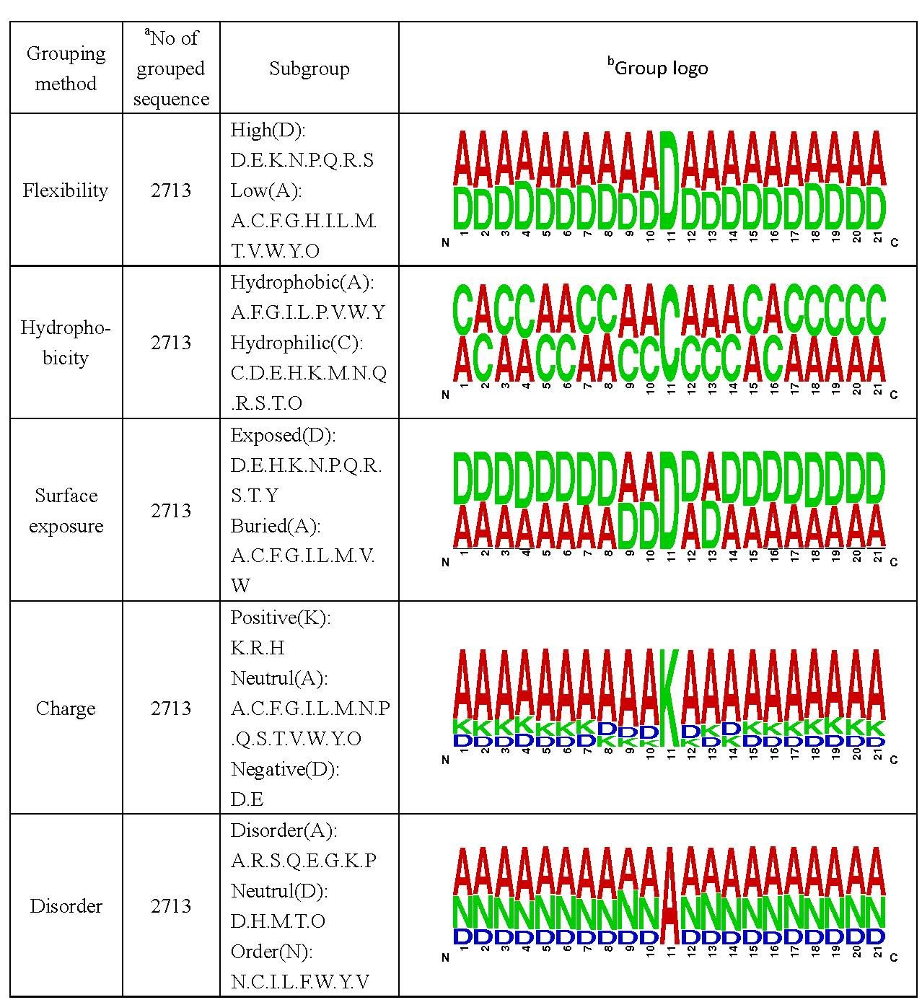
Fig.S1. The graphical representation of biochemical environment surrounding succinylation sites using different grouping method. ªRedundant sequence is eliminated from each group sequence. ^{b}Each symbol in the stack of group logo represents each class in the group column.

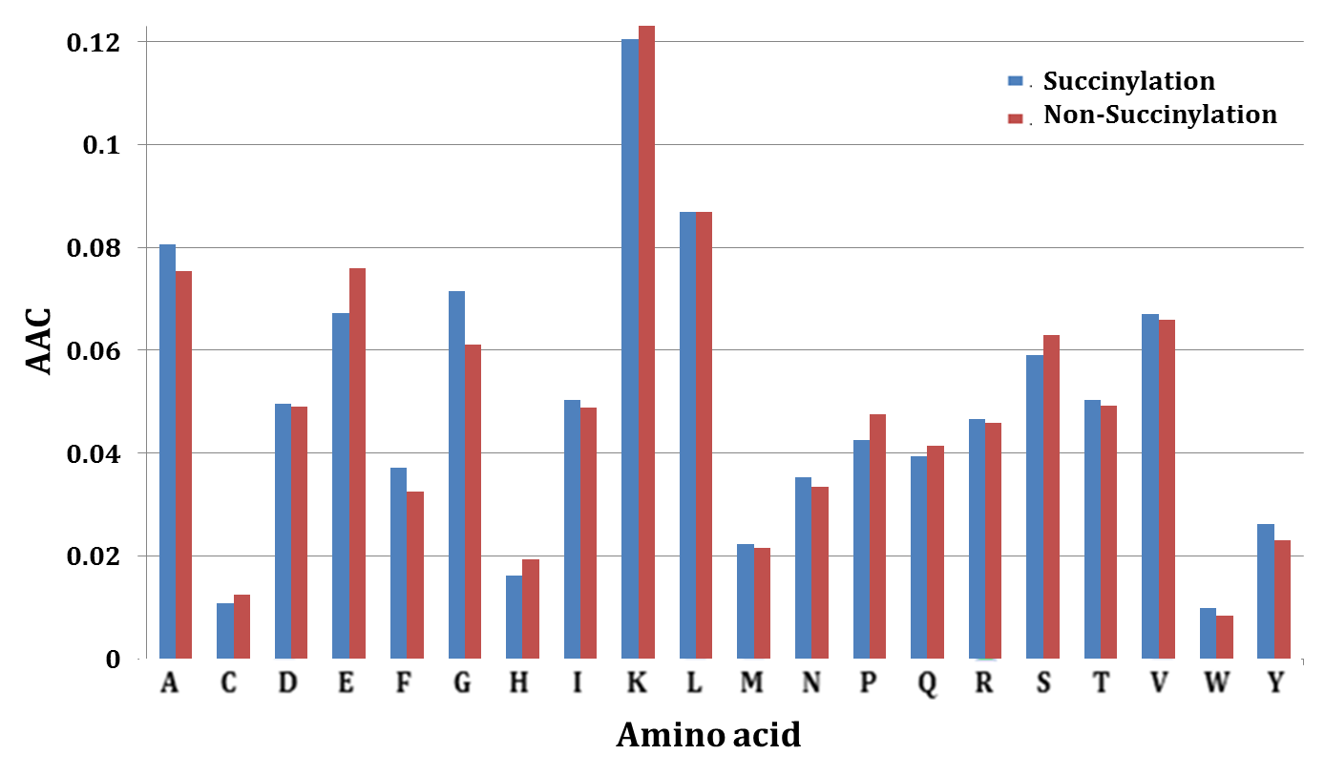
Fig.S2. Amino acid average composition of succinylation and non-succinylation sites.

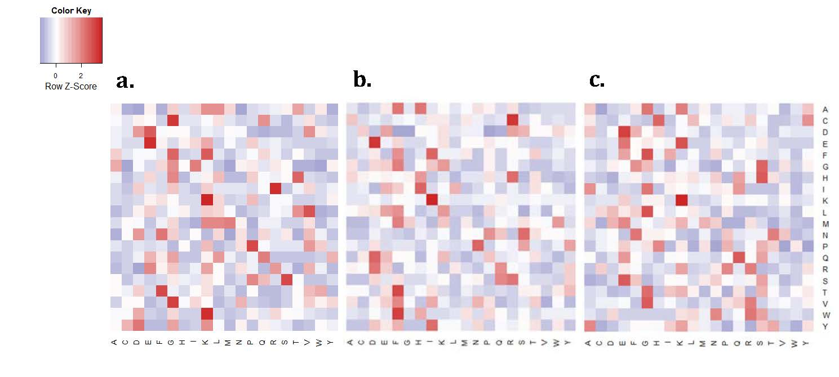
Fig.S3. Heatmap indicating the weight distribution of k-space scores of amino acid pairs. (a) k=1. (b) k=2. (c) k=3.
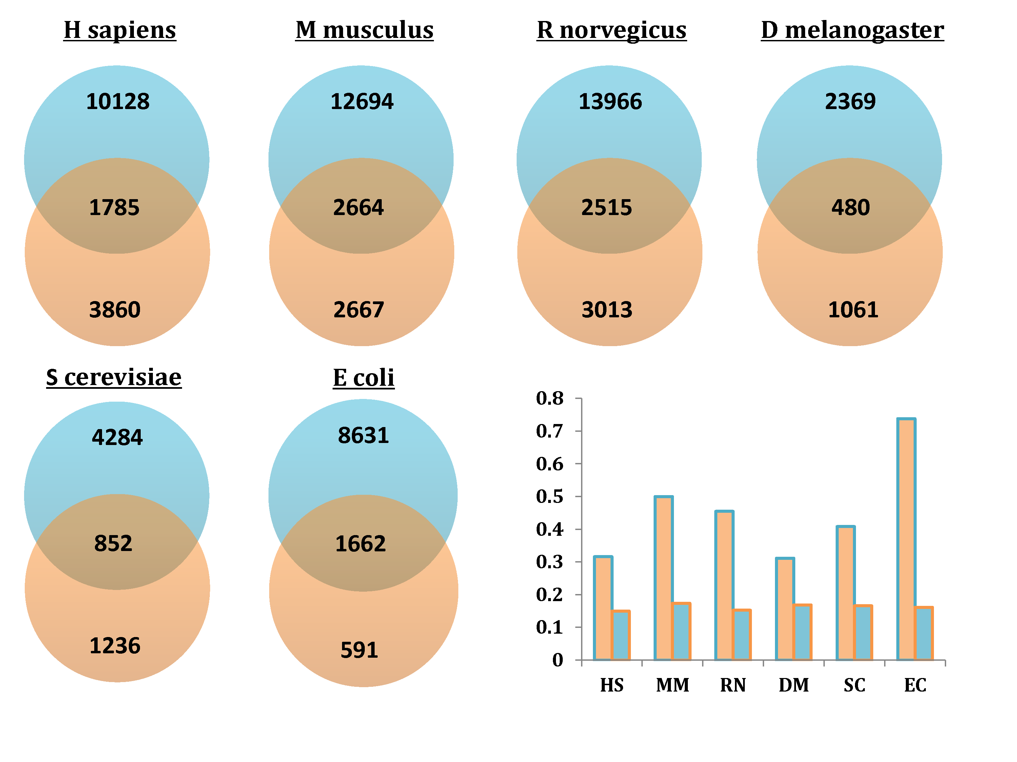
Fig.S4. The in situ crosstalk between succinylation with acetylation across different species. (a) The Venn diagrams show the in situ crosstalk between succinylation and acetylation sites in H. sapiens (HS), M. musculus (MM), R norvegicus (RN), D. melanogaster (DM), S cerevisiae (SC) and E coli (EC). The histogram shows the fraction of in situ crosstalk sites occurring on disparate lysine modifications. Red, acetylation. Mint, succinylation.

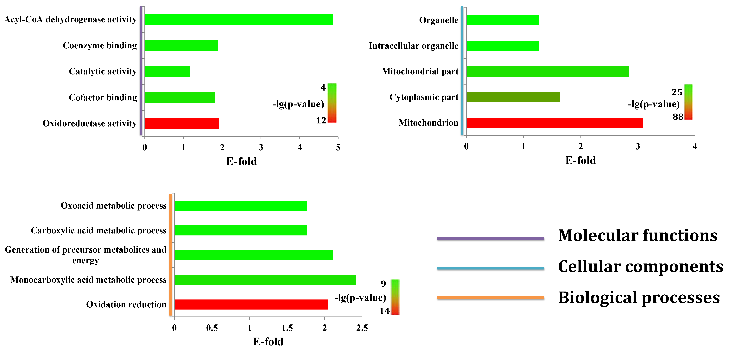
Fig.S5. The enriched GO terms for proteins with in situ crosstalk between succinylation- acetylation in comparison with acetylated proteins. E-fold, Enrichment fold.
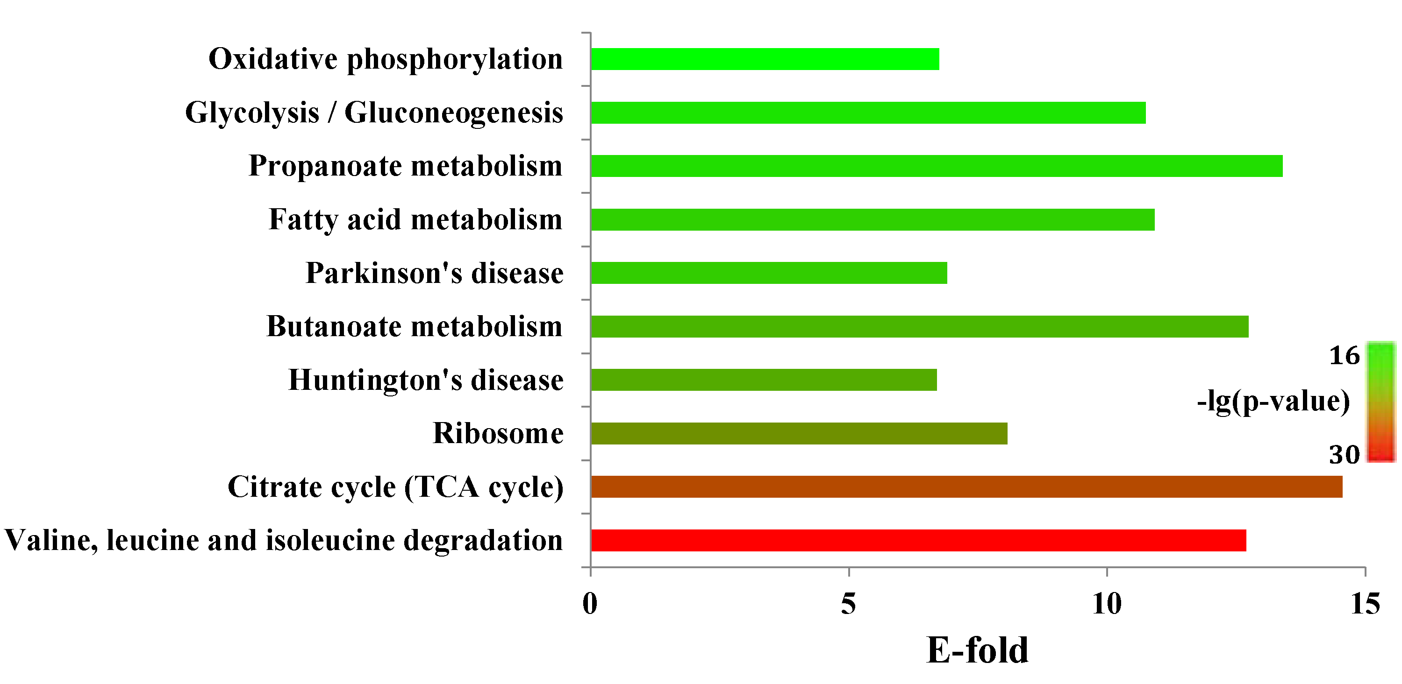
Fig.S6. The enriched KEGG annotations for proteins with in situ crosstalk between succinylation -acetylation in comparison with acetylated proteins. E-fold, Enrichment fold.

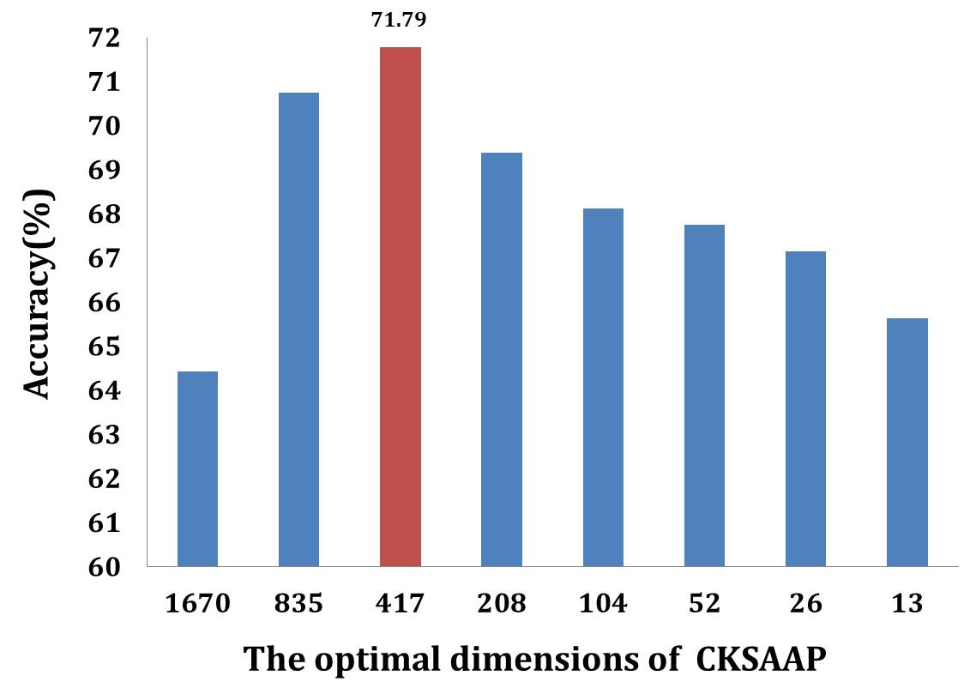
Fig.SS1. Optimization of CKSAAP encoding by F-score strategy with 10-fold cross-validation..
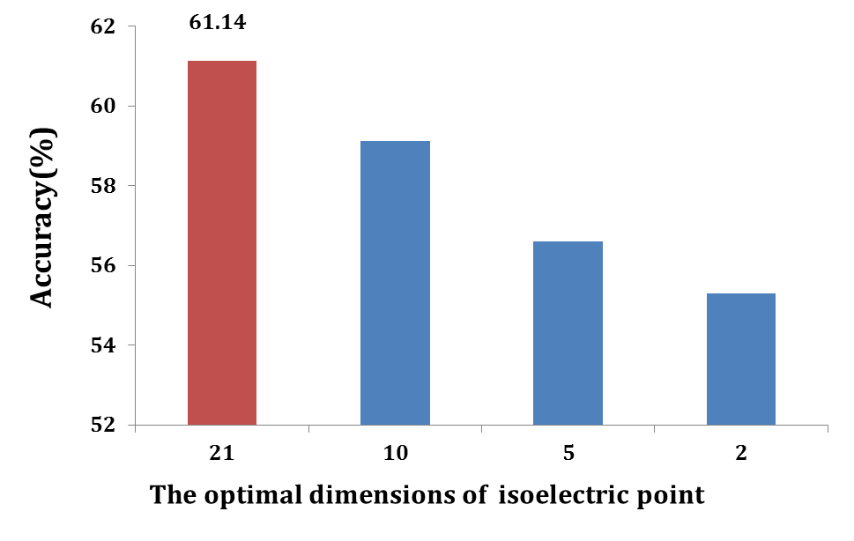
Fig.SS2. Optimization of isoelectric point by F-score strategy with 10-fold cross-validation.

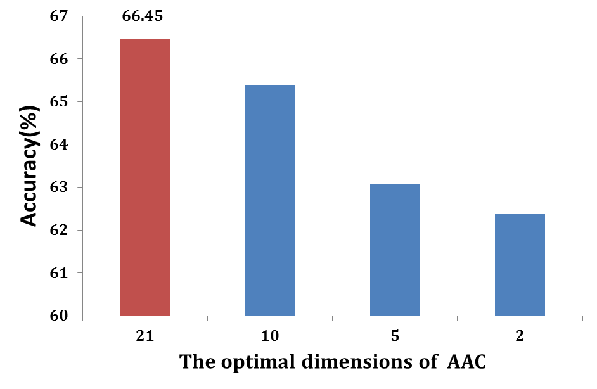
Fig.SS3. Optimization of AAC by F-score strategy with 10-fold cross-validation.

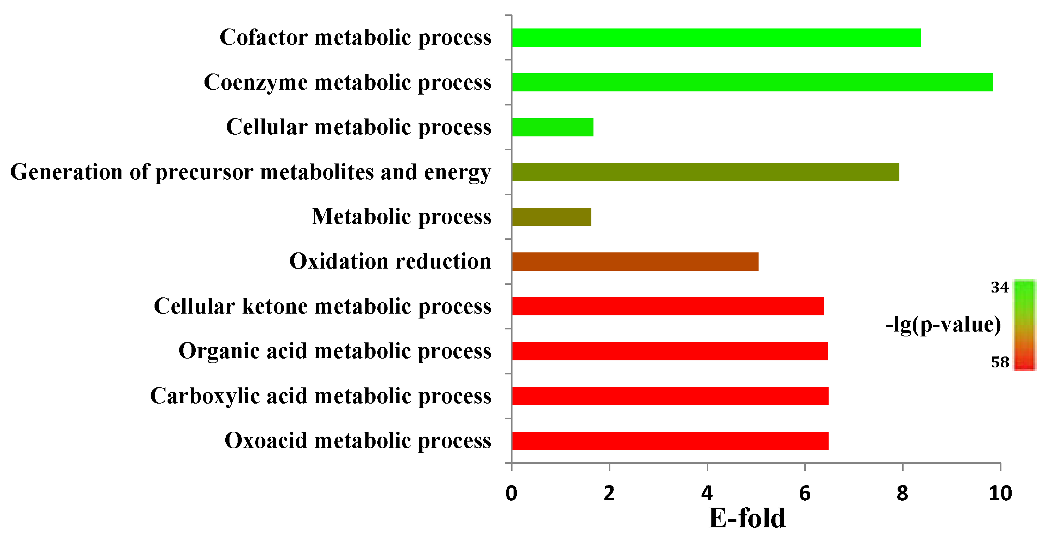
Fig.SS4. Statistical analyses of GO annotations (Biological processes) for succinylated proteins. E-fold, Enrichment fold.

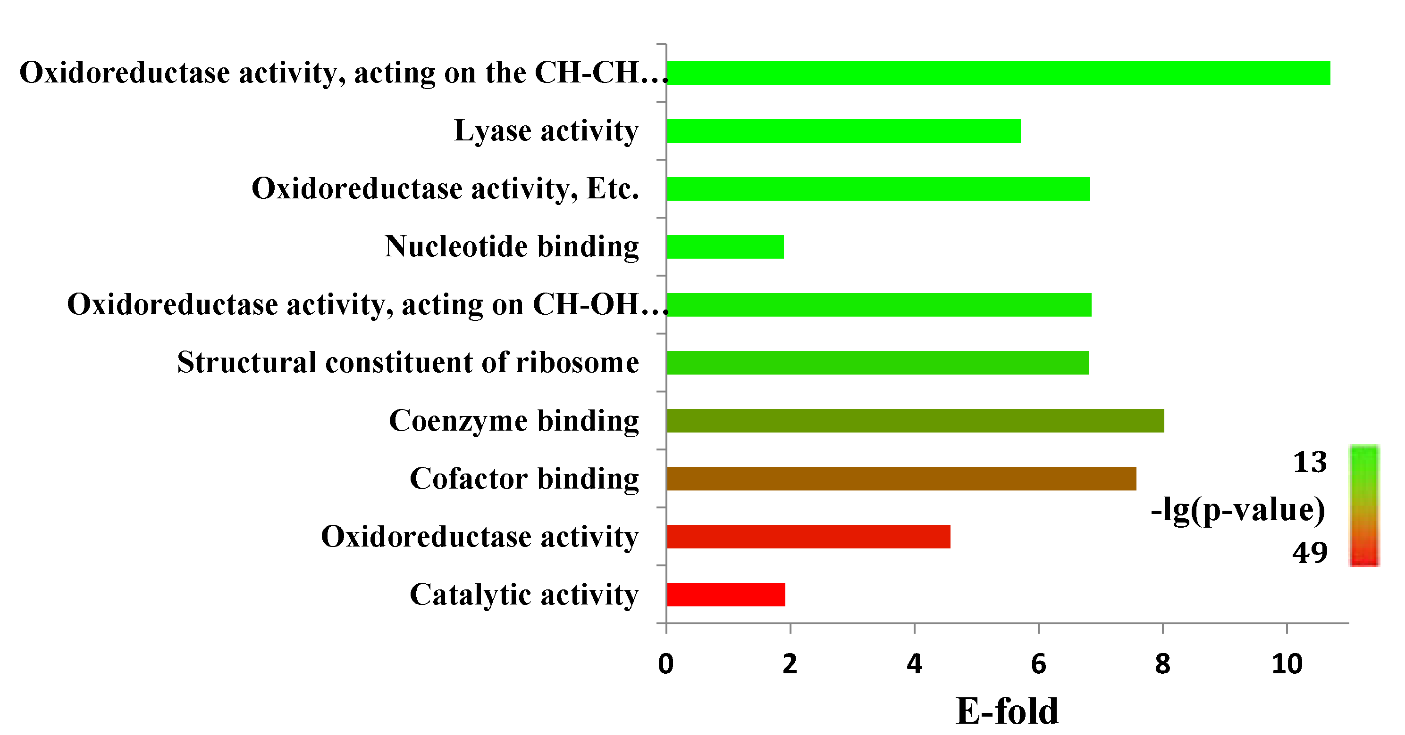
Fig.SS5. Statistical analyses of GO annotations (Molecular functions) for succinylated proteins. E-fold, Enrichment fold.

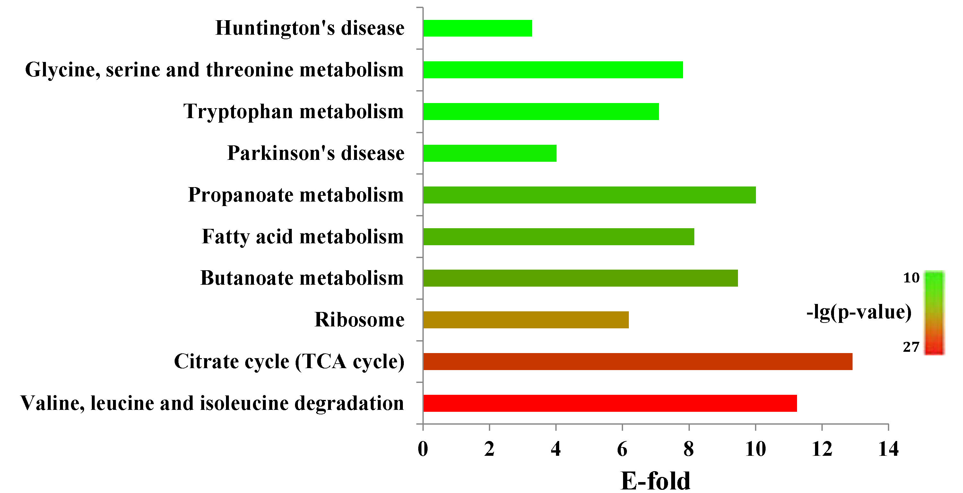
Fig.SS6. Statistical analyses of KEGG annotations for proteins of succinylated. E-fold, Enrichment fold.

- Supplementary References
Chen, K., et al. (2009) Prediction of integral membrane protein type by collocated hydrophobic amino acid pairs, Journal of Computational Chemistry, 30, 163–172.
Jiang, F., Sui, Y. and Cao, C. (2010) An information entropy-based approach to outlier detection in rough sets, Expert Systems with Applications, 37, 6338–6344.
Kawashima, S. and Kanehisa, M. (2000) AAindex: amino acid index database, Nucleic acids research, 28, 374-374.
Shannon, C.E. (1997) The mathematical theory of communication (Reprinted), M D Computing, 14, 306-317.
Sokolova, M., Japkowicz, N. and Szpakowicz, S. (2006) Beyond accuracy, F-score and ROC: a family of discriminant measures for performance evaluation. In, AI 2006: Advances in Artificial Intelligence. Springer, pp. 1015-1021.

